**Implementation of a Clinical Decision Support System (CDSS) for cancer wards**

**Names and Student Numbers:**

s225227053-Naidoo Max Christopher

s225256797-Nkanini Avela

s225905272-Nxam Asemahle

s225041308- Zide Yandisa

s224331787-Zolwana Saneze

Quality Improvement Project Report

VMHC300

Department of Nursing Science

Of the

FACULTY OF HEALTH SCIENCES

at the

NELSON MANDELA UNIVERSITY



Lecturer: Mrs M Kramer

Lecturer: Mrs K Gerber

October 29

**ABSTRACT**

In this research, we investigated how a Clinical Decision Support System (CDSS) can support doctors and nurses, especially in cancer wards. The system assists them in assessing patient symptoms and offers treatment suggestions and diagnostic alerts. By notifying doctors when patients show signs of cancer, the system aims to improve patient care, reduce errors in diagnosis, and speed up the process of identifying the disease. Feedback was given on the CDSS while conducting interviews and this is reflected upon during evaluation where the limitations encountered are also addressed. The concerns of using the CDSS are discussed in detail under how it would impact nursing management. The report concludes the effectiveness of the system and how it would improve and support the delivery of quality care within the oncology ward.

# DECLARATION

We, the undersigned hereby declare that the attached document, namely Implementation of a Clinical Decision Support System (CDSS) for cancer wards, dated 29 October is composed of our work, and when other authors have been consulted, we have paraphrased and referenced accordingly. This document contains no breach of copyright.

Furthermore, I am aware that any evidence of plagiarism contained herein will render this submission, in its entirety, to be discredited, and will warrant disciplinary action.

All references and quotations have been attributed to their source, cited and included in the list of references.

Signed this Nkanini Avela, Naidoo Max Christopher, Nxam Asemahle, Zide Yandisa, Zolwana Saneze day of 29 October at the Nelson Mandela University.

Table of Contents

ABSTRACT 1

DECLARATION iv

Table of Figures vi

Table of Tables vi

1.CLARIFICATION OF CONCEPTS 1

2.INTRODUCTION 1

3.QUALITY STANDARD(S) APPLICABLE TO REPORT / PROJECT 2

4.THE PROBLEM NOTED 4

5. MANAGEMENT STRATEGY 6

5.1 THE AIM (GOAL) OF THE PROJECT 6

5.2 DECISION-MAKING CRITERIA 7

5.3 POSSIBLE SOLUTIONS AND OPTIONS 8

5.4 SELECTION OF THE BEST SOLUTION 11

5.5 PRE-IMPLEMENTATION OF THE SOLUTION 11

5.6 IMPLEMENTATION OF THE SOLUTION 13

*Questionnaire* 13

5.7 EVALUATION 14

Constraints 15

Recommendations 15

6.IMPACT 17

Nursing Management 17

Nursing Care 17

Patient Outcomes 17

7.CONCLUSION 19

References 20

Annexure A 22

Annexure B 25

Annexure C 41

# Table of Figures

Figure 1: Gantt chart of QIP project 17

# Table of Tables

Table 1: to see the full source timeline visit the web document ( SOUTH-AFRICAN-CANCER-CONTROL-ROADMAP, 2019) 6

Table 2: Decision Matrix - Delay in cancer diagnosis 10

# 1.CLARIFICATION OF CONCEPTS

**Clinical Decision Support System (CDSS):** A combination of Health and Information Technology that provides practitioners with knowledge and patient-specific information. It is used to make more accurate clinical decisions and improve patient safety (Margaret Rouse, 2016).

**Computerised provider order entry (CPOE):** Application that allows health care providers to enter medical orders electronically. This includes sending treatment instructions and laboratory orders (Megan Charles, 2018).

**Human-Computer Interaction (HCI):** HCI is the design and improvement of interaction between computers and humans. It allows computers to be more user-friendly and efficient. It is crucial when considering the design of software involving decision-making with an easy-to-use framework. This will help improve usability in carrying out healthcare processes (Daniel Chandler & Rod Munday, 2011).

**Oncology:** The study and treatment of cancer including the various therapies and procedures used to treat cancer (National Cancer Institute, 2011).

**Evidence Based medicine (EBM):** Uses clinical experience and data to improve healthcare decisions. The evidence is then used and applied to evaluate the performance during clinical practice (Tenny & Varacallo, 2022).

For the QIP project, we will be look at implementing CDSS within the hospital. Our focus would be on critical decision-making when diagnosing and treating cancer patients. We will also look at how CDSS helps improve patient safety when delivering effective oncology care and how it will improve the overall quality when used in hospitals. Management of the risk in late cancer diagnosis will also be compared to having the CDSS in place.

# 2.INTRODUCTION

Cancer misdiagnosis may occur at any stage during the cancer misdiagnosis process. Human error, such as a doctor’s negligence or incompetence when deciding which kinds of cancer tests would be needed, can result in cancer misdiagnosis. Misdiagnosis of cancer may occur during the testing process, such as errors in performing diagnostic imaging or poor cell sample collection for a biopsy.

Our topic is about designing a clinical decision support system (CDSS) directed towards cancer patients, with adherence to Evidence-Based Medicine guidelines. According to (Dotson, 2015), Evidence-Based Medicine is the conscientious, explicit, and judicious use of current best evidence in making decisions about the care of individual patients. The main objective of this system is to provide concrete medical information and aid in the diagnosis of cancer patients, in other words, improving the quality of care they receive.

The following aspects are discussed in the report below, quality standards applicable to the project, identification of the problem including factors that contribute to the problem, and clarification of the most important concepts. By addressing these aspects comprehensively, the purpose of this report is to provide a thorough overview and understanding, planning, and execution of a CDSS tailored for cancer patients, thereby improving patient care and clinical outcomes in oncology practice.

# 3.QUALITY STANDARD(S) APPLICABLE TO REPORT / PROJECT

Quality standards ensure that things are done the same way every time, support best practices, and encourage teamwork in different areas (Jerry, 2020). Besides working to prevent illness, cancer diagnosis and treatment programs also focus on improving the quality of life for those who have survived cancer. (Organization, 2024). Establishing certain standards is crucial as we implement the Clinical Decision Support System (CDSS), which is designed for treating cancer. The main rules that nurses must adhere to when diagnosing and treating cancer will be emphasized in this section.

National Cancer Control Program (NCCP)

The government created a plan called the National Cancer Control Program (NCCP) to focus on preventing cancer, finding it early, and providing treatment and care for patients across the country (Agency, 2023). This program includes strategies, policies, and initiatives designed to reduce the effects of cancer and improve patient outcomes (Programme, 2023). The NCCP focuses on important goals for managing cancer, such as encouraging healthy lifestyles to help prevent it, starting screening programs for early detection, ensuring that people have access to quality care and support, and boosting research to track cancer trends (Technicians, 2024). Overall, the NCCP provides a strong framework for a more coordinated and unified approach to cancer control. It aims to lower cancer rates and deaths, improve the quality of life for patients and survivors, and lessen the social and economic impact of the disease on individuals and communities.

South African Nursing Council (SANC) Guidelines:

The South African Nursing Council (SANC) guidelines offer a framework for nurses providing cancer care, ensuring that care is focused on patients and meets high standards (Council S. A., 2020). Oncology nurses follow the SANC's guidelines for practice and receive specialized education and training (Staff, 2023). They adhere to ethical principles while caring for cancer patients, respecting their rights and encouraging informed choices (Mary Johnson, 2024). Nurses are encouraged to keep learning to stay informed about the newest developments in cancer care (DAVIDS, 2006). Teaming up with other healthcare workers ensures that patients receive comprehensive and coordinated care throughout their cancer journey, which ultimately leads to better outcomes for patients in South Africa (Council, 2024).

Evidence-Based Practice (EBP) Guidelines

Nursing care is based on Evidence-Based Practice (EBP) Guidelines, which use real-life knowledge, patient needs, and research to help nurses make decisions. Nurses look at research to create care plans that suit each patient (Dr. Tiffany Avery, 2020). To use EBP suggestions, nurses need to follow set steps and regularly check how well patients are doing (Victoria, 2021). Healthcare groups make and share these guidelines, and nurses should keep up with the latest advice that matters to their work (Randa Elsheikh, 2023). By using the best evidence for treatments, EBP guidelines help make patient care safer and better (Town, 2022).

Table 1: to see the complete source timeline, visit the web document (SOUTH-AFRICAN-CANCER-CONTROL-ROADMAP, 2019)

|  |  |  |
| --- | --- | --- |
| **South African Cancer Control Timeline Summarised** | | |
| **Year** | **Event** | **Outcome** |
| 1986 | Pathology-Based National Cancer Registry established | Pathology Based National Cancer Registry established. |
| 1991 | South African Bone Marrow Registry (SABMR) established | 65,000 South African donors are registered, and access to 20 million global donors is available. |
| 1993 | Tobacco Control Act 83 of 1993 | South Africa was the first country to regulate tobacco use and sales. SA joined WHO Tobacco Convention in 2005 |
| 1998 | The first National Cancer Control Plan (NCCP) was developed and approved | The cervical cancer policy was implemented with national screening guidelines. |
| 2011 | CANCER ALLIANCE established. | Calls to update NCCP; NDoH calls for unified cancer community consultation. |
| 2016 | Consultative meetings on Breast Health Policy held. | Commitment for policy finalisation by March 2016, but no further developments. |

# 4.THE PROBLEM NOTED

The current problem in the field of Oncology

Currently, the problems that health practitioners face within the oncology wards have to do with the late detection of cancer which leads to complications of treatment. Long-term it can lead to hospital admissions, about 13,9%-21.8% of patients are diagnosed with cancer during emergency admissions (Michael Yule et al., 2017).

**4.1 Problem**: Delay in diagnosing cancer in a patient.

**Nature of the problem**: The problem involves a delay in the diagnosis of cancer because of the patient’s poor background and lack of income from home which leads to the inability to afford medicals and chemotherapy for the patient, which can lead to delayed initiation of treatment and potentially worsen patient outcomes. Delays can occur at various stages, including the recognition of symptoms by the patient or health practitioner, referral to specialists, and completion of diagnostic tests (Chieh-Liang Wu, 2021).

**Extent and intensity** of **the problem**: A delay in diagnosing cancer can significantly impact patient health and well-being. It can lead to the progression of the disease, a need for more aggressive treatment, and a lower chance of survival. (Neal, 2015) The problem affects not only the patient but also their family and caregivers. For example, a delayed cancer diagnosis can be exemplified by colorectal cancer. A study published in the British Journal of Cancer found that delays in diagnosing colorectal cancer significantly affected survival rates. Those who received their diagnosis over a year after their symptoms first showed a poorer prognosis compared to those identified within three months. More specifically, the five-year survival rate dropped from 85% for patients diagnosed within three months to 40% for patients diagnosed a year later. (Neal, 2015)

**Factors/variables contributing to the problem**:

* **Healthcare environment**: Lack of access to diagnostic tools or specialised healthcare services, long waiting times for appointments or test results. (O’Malley, 2005) discovered that unequal distribution of diagnostic equipment and rare health care services has inadequate effects on the diagnosis and treatment of cancer individuals. There was also an emphasis on patients from rural settings which spend an extended period at health facilities due to lack of nearby clinics and trained specialists.
* **Human resources**: Inadequate training or awareness among healthcare providers regarding cancer symptoms, diagnostic guidelines, or patient communication.
* **Patient factors**: that can further influence the problem are lack of awareness about cancer symptoms, fear or stigma associated with cancer, reluctance to seek medical attention.

**4.2 Root Cause Analysis:**

1. Problem: Delay with cancer detection in patient.
2. Causal Factors: Determine the underlying causes of delays, such as healthcare system issues, patient-related factors, or healthcare provider-related factors.
3. Healthcare System Issues:

* Delays in the scheduling of appointments with specialists for patients.
* Availability of resources such as tools to support the diagnostic process.

1. Patient-Related Factors:

* Gather insight into patient knowledge and misconceptions when reaching out for care.
* Take into consideration transport challenges and access to primary healthcare facilities.
* Evaluation of current scheduling systems and time taken for diagnosing.
* Conduct interviews and make use of questionnaires when gathering information on patients regarding the diagnostic process.

**4.3 Develop Solutions**: To address the root causes, such as implementing screening programs, improving access to healthcare services, or enhancing patient education and awareness. The purpose is to create a system that helps practitioners assist in diagnosing cancer in patients and show which symptoms are the probable causes.

Our primary purpose was to create a mobile application to help doctors diagnose the patient and show which symptoms a patient has about the cancer.

**4.4 Implement Solutions**: Implement the proposed solutions and monitor their effectiveness.

**4.5 Evaluate Outcomes:** Assess the impact of the implementation on reducing delays in diagnosing cancer. (Brown & Johnson, 2022)

# 5. MANAGEMENT STRATEGY

## 5.1 THE AIM (GOAL) OF THE PROJECT

The main aim of this project was to bring forward the objectives that the Clinical Decision Support System (CDSS) underlines. The diagnostic procedure has a multitude of fallacies that result in recurrent human lapses and incompetencies guaranteeing cancer misdiagnosis. This has been known to expose the health and well-being of patients to risk (Hall et al). The employment of certain technologies and evidence-based methods can help this issue. This project availed itself to address and counteract such challenges, enhancing the timeless and accuracy of cancer discovery.

**USING SMART PRINCIPLES:**

* **SPECIFIC**: The project’s approach is working to condense the average time taken to arrive at a diagnosis from the onset of visible symptoms by 20% within a 12months period
* **MEASURABLE**: The success of the project will be guarded by tracking the course of time that transpires between the onset of symptoms and diagnosis prior and subsequent the CDSS that has been implemented. The reduction target is set at 20% and will be observed through data analysis.
* **ACHIEVABLE**: The success of the project and its objectives can be met by executing a CDSS curated for the demands of healthcare practitioners. It will do so by streamlining the procedure for diagnosis, the provision of evidence-based decision support for healthcare practitioners and ultimately by facilitation of timely referrals and intervals.
* **REALISTIC:** In the habit of the potential benefits of CDSS in enhancing the process of diagnosis patient outcomes and efficiency attaining a percentage of 20 as a standard time of diagnosis, it will have reached the project’s target which is both reasonable and feasible.
* **TIMELY:** 10 months is the set timeline span of the project, commencing February 2024 to November 2024, laying provision for abundant time in implementation and evaluation of the CDSS. Development of adjustments and assessments will make certain convenient achievement of the goal.

## 5.2 DECISION-MAKING CRITERIA

The chosen option considers the practical feasibility and the impact it would have on quality management. The system will match symptoms and bring patient awareness. This will potentially prompt earlier medical consultation or intervention. People are diagnosed late because they are unaware which type of cancer they have. This application will help both patients and doctors see the potential symptoms of a patient’s cancer.

Table 2: Decision Matrix - Delay in cancer diagnosis

|  |  |  |  |  |  |
| --- | --- | --- | --- | --- | --- |
| **Decision Matrix: Delay in cancer diagnosis** | | | | | |
| Criteria | Practical  Feasibility  3 | User-Friendliness  2 | Impact on Quality Management  5 | Data Security and privacy  4 |  |
| Problems |
| Worsening symptoms | 3 x 3 = 9 | 2 x 2 = 4 | 3 x 5 = 15 | 2 x 4 = 8 | 36 |
| Extended pain and suffering | Medium –  Real-time updates and monitoring of patient conditions  2 x 3= 6 | 1 x 2 = 2 | 2 = 5 = 10 | 1 x 4 = 4 | 22 |
| Emotional suffering | 2 x 3 = 6 | 2 x 2 = 4 | 3 x 5 = 15 | 3 x 4 = 12 | 37 |
| Increased mortality risk | 3 x 3 = 9 | 3 x 2 = 6 | 3 x 5 = 15 | 1 x 4 = 4 | 34 |

**Method 1**: A Rating scale for the criteria

1, 2, 3, 4, 5 (1 = low to 5 = great)

**Method 2**: A Rating scale for the problem

1, 2, 3 (1 = low, 2 = medium, 3 = high)

For the table above it emotional suffering scored the highest. Therefore, it would be best to consider how this would be solved when designing the system.

## 5.3 POSSIBLE SOLUTIONS AND OPTIONS

To address time constraints when diagnosing patients unfamiliar with cancer treatment, the proposed solutions will improve upon the existing diagnostic process.

By keeping medical practitioners, especially nurses, informed on current developments in cancer research, a CDSS will help better understand all possible cancer symptoms. It also helps deal with the possibility of patient errors by providing the symptoms that they have noticed themselves. A misinterpretation of symptoms, improperly conducted tests and failure to offer cancer screenings are some of the most common causes of cancer misdiagnosis (Wilson, 2018).

5.1 Solutions to the problem of late or misdiagnoses of cancer in patients: (These will all make use of the CDSS system)

1. Having an alert system to notify health practitioners if their patient matches key cancer symptoms or prompt a specialist to review the symptoms.
2. Allow specific information to be displayed about the diagnosis, treatment, and long-term side effects. This will help develop a plan moving forward so that a constructed decision is made with evidence-based recommendations.
3. Have a prompt that assists in making possible recommendations for early testing based on the symptoms of the patient and their medical history.
4. An Electronic Health Record system, with real-time updates, will ensure effective communication among healthcare professionals and track the patient's journey. It would also alert and notify the severity of a patient's current condition when arriving at the hospital, this allows management to delegate who is best suited to care for the patient now.
5. Have the CDSS notify healthcare providers when the symptom of a patient worsens or if they show more symptoms related to cancer, allowing a more effective way to prevent the condition from worsening.

|  |  |  |  |  |  |
| --- | --- | --- | --- | --- | --- |
| **Member 1: Max Naidoo** | | | | | |
| **Decision-making criteria** | **Option 1:** **Notify symptom matches** | **Option 2: Inform/educate on cancer** | **Option 3: Prompt for additional testing** | **Option 4: EHR for patient condition** | **Option 5: Symptom severity tracking** |
| Feasible | 7 | 6 | 10 | 5 | 8 |
| Cost-effective/ affordable | 4 | 8 | 5 | 4 | 4 |
| Enhances quality management | 8 | 5 | 7 | 6 | 8 |
| Aligned with the institution’s values | 9 | 7 | 6 | 8 | 7 |
| **Total score per option for group member 1** | **28** | **26** | **28** | **23** | **27** |
| **Member 2: Nkanini Avela** | | | | | |
| Feasible | 8 | 7 | 7 | 6 | 9 |
| Cost-effective/ affordable | 6 | 6 | 4 | 3 | 4 |
| Enhances quality management | 7 | 3 | 8 | 7 | 9 |
| Aligned with the institution’s values | 8 | 9 | 5 | 7 | 7 |
| **Total score per option for group member 2** | **29** | **25** | **24** | **23** | **29** |
| **Member 3: Sanele Zolwana** | | | | | |
| Feasible | 9 | 5 | 8 | 6 | 8 |
| Cost-effective/ affordable | 6 | 7 | 4 | 4 | 5 |
| Enhances quality management | 10 | 6 | 6 | 8 | 7 |
| Aligned with the institution’s values | 9 | 6 | 8 | 7 | 7 |
| **Total score per option for group member 3** | **34** | **24** | **26** | **25** | **27** |
| **Member 4: Yandisa Zide** | | | | | |
| Feasible | 5 | 6 | 10 | 7 | 7 |
| Cost-effective/ affordable | 4 | 7 | 6 | 3 | 4 |
| Enhances quality management | 7 | 5 | 7 | 6 | 7 |
| Aligned with the institution’s values | 8 | 7 | 6 | 7 | 7 |
| **Total score per option for group member 4** | **24** | **25** | **29** | **23** | **25** |
| **Member 5: Nxam Asemahle** | | | | | |
| Feasible | 8 | 6 | 9 | 5 | 8 |
| Cost-effective/ affordable | 5 | 8 | 4 | 4 | 5 |
| Enhances quality management | 8 | 7 | 8 | 7 | 8 |
| Aligned with the institution’s values | 9 | 8 | 7 | 7 | 7 |
| **Total score per option for group member 5** | **30** | **29** | **28** | **23** | **28** |
| **TOTAL GROUP SCORE EACH OPTION** | **145** | **129** | **135** | **117** | **136** |

## 5.4 SELECTION OF THE BEST SOLUTION

Implementing an alert system to notify health practitioners if their patient matches key cancer symptoms will significantly streamline the work of practitioners by reducing the need for extensive testing to diagnose cancer. This system allows patients to undergo initial screenings, and if cancer is detected, it can recommend appropriate treatment methods or prompt a specialist to review the symptoms. As a result, healthcare providers can quickly identify and address potential cancer cases, enhancing the efficiency of the diagnostic process (Chieh-Liang Wu, 2021).

Furthermore, an alert system minimizes the chances of medical errors by producing clear, accurate, and legible information. This ensures that patients receive timely treatment, as practitioners will be promptly notified if a patient shows signs of cancer, enabling early intervention before the disease progresses. Additionally, this system improves the overall quality of care, reducing the likelihood of complaints related to diagnostic errors or delays, and fostering a more efficient and patient-centred approach in the organization (Chieh-Liang Wu, 2021).

## 5.5 PRE-IMPLEMENTATION OF THE SOLUTION

In this pre-implementation section, we outline the app’s purpose and functionality. The app is designed to support healthcare practitioners by analysing patient-reported symptoms to determine the most likely cancer types. It also provides potential treatment options, helping patients concerned about their health, especially those seeking early cancer detection. The app includes important features like symptom input, cancer probability results, treatment recommendations, and the option to

schedule appointments with specialists.

Users start their journey with a welcome screen that introduces the app. After clicking "Next," they are directed to a login page where they can sign in or create a new account. After logging in, users must check their phone number. This step is important for protecting their accounts and helps them get back into their accounts if they forget their passwords. It also lets the app send them important messages by gathering their phone numbers, email addresses, and usernames.  
After verifying their phone number, users will go to the home page, which is the main menu. From this page, they can choose options like diagnosing symptoms, checking results, getting treatment recommendations, finding specialists, or scheduling appointments. There is also a calendar to help users remember their upcoming healthcare activities.  
  
In the diagnosis section, users can put in their symptoms and answer easy questions. They will say yes or no, how long they have had the symptoms, and how much pain they feel. This helps the app collect the right information for a better diagnosis. This ensures the app gathers accurate data, leading to more reliable diagnosis results. This comprehensive input process helps ensure more accurate diagnosis results. This detailed process ensures accurate data collection for better diagnosis results.  
  
The results page displays cancer probabilities in easy-to-understand graphs. From here, users can click “Recommendations” to view more details, including information on nearby specialists and available testing methods. The specialist section provides contact details and availability, and the scheduling feature allows users to book appointments directly.  
  
To gather feedback from healthcare professionals, we’ve created a questionnaire (Annexure A), which can be completed through interviews or after testing the app. The feedback will show if the app is helpful for oncology practices or if there are areas that need improvement. We also plan to interview oncology specialists to get their insights.  
  
This part explains our plan before implementation, focusing on gathering feedback to improve the app and make sure it’s useful for both healthcare professionals and patients.

## IMPLEMENTATION OF THE SOLUTION

The implementation was conducted in two parts; using a questionnaire and testing the high-fidelity prototype (Annexure C). The group members were not permitted to test the prototype within the oncology wards of neither public nor private hospitals. Therefore, testing was done among four nursing students in an interview setting and one nursing staff member who works at one of the public hospitals in Nelson Mandela Bay. The nursing students had three years of working experience, and the staff member had 10+ years of experience. The interview included the answering of the questionnaire (Annexure A).

### Questionnaire

The questionnaire (Annexure B) was answered after the prototype was tested. It consisted the answering of a table with checkboxes based off the nurses opinions. The nurses could then answer long questions about whether they thought the system could be implemented effectively or had any concerns. For each statement from the table (Annexure A), For each statement from the table (Annexure A), the following is a summary of the answers:

* None had experience using a CDSS in practice.
* All agreed that a CDSS would help deliver quality care, with two strongly agreeing to the statement
* In terms of the easiness in implementing the system, two remained neutral and one agreed to it. The rest disagreed and figured it would be difficult.
* All agreed that the system would positively impact the decision-making process.
* All agreed this will be helpful when engaging with patients’ treatment plans.

The answers to general questions addressed some of the nurses’ concerns. These questions covered the scope of recommending the CDSS to the risks and feasibility of implementation. The following is a summary on how the questions were answered:

1. Such as the willingness of the staff to change and be trained to use the system, the training and cost-effectiveness of the system, whether it will be for public or private hospital, and how secure patient data is being stored.
2. Most nursing students did not engage as often with patients of the oncology ward due to shifts, but one did engage regularly as part of clinical placement. The nursing staff member engages daily with the patients in the oncology ward.
3. All agreed there would be a steep learning curve among the older nurses, specifically in public hospitals, where technology is not utilised as much.
4. All the nursing students interviewed would recommend the CDSS to their colleagues, while the staff member was more reluctant. This could be due to their colleagues being of a higher age group.
5. There are concerns about the risks of leakage of patient data, lack of access to devices using the system, duration of implementation and system crashes. One of the leading general risks or concerns encountered was the accuracy of the information being presented to patients, and this is an essential issue as inaccurate data could lead to fatal mistakes.
6. All agreed that the system could be applied to more than just the oncology ward. Some suggestions included using it in primary health care, maternity wards, and general mental health assessments.

The interview of the nursing staff member was conducted on August 16 2024, and the interview of the nursing students was conducted on October 15 2024. Therefore, the span of the pre-implementation and implementation took a total of 2 months.

## 5.6 EVALUATION

This QIP project had the goal of showing the impact a Clinical Decision Support System (CDSS) would have if it were implemented within our healthcare facilities. Specifically in the oncology wards of either private or public system (CDSS) would have if implemented within our healthcare facilities. Specifically in the oncology ward for either private or public hospitals. Some challenges hindered us from implementing it fully, so we had to use a combination of testing the system in an interview setting and with questionnaires.

Therefore, the goal was only partially achieved with the information gathered from the questionnaires. This was due to some constraints during the project. The valuable feedback from the nursing staff members and students gave insight into the factors that must be considered when implementing recommendations or improvements.

### Constraints

One of the main issues encountered was not having permission to enter the hospitals. Since we did not have permission from the nursing management to carry out the implementation, the accuracy of the research was affected due to the small dataset gathered. The nursing lecturer overseeing this project has been trying to get permission specifically for the BIT students for months. Still, the head of the BIT faculty would also need to be involved to gain permission.

There were also time-constraints and conflicting module schedules, which may have affected the outcome. Since some group members had different modules, not everyone could work at the same pace. Due to this, a roadmap was developed to delegate tasks to keep the project progressing. This allowed us to see if we were falling behind and how much needed improvement.

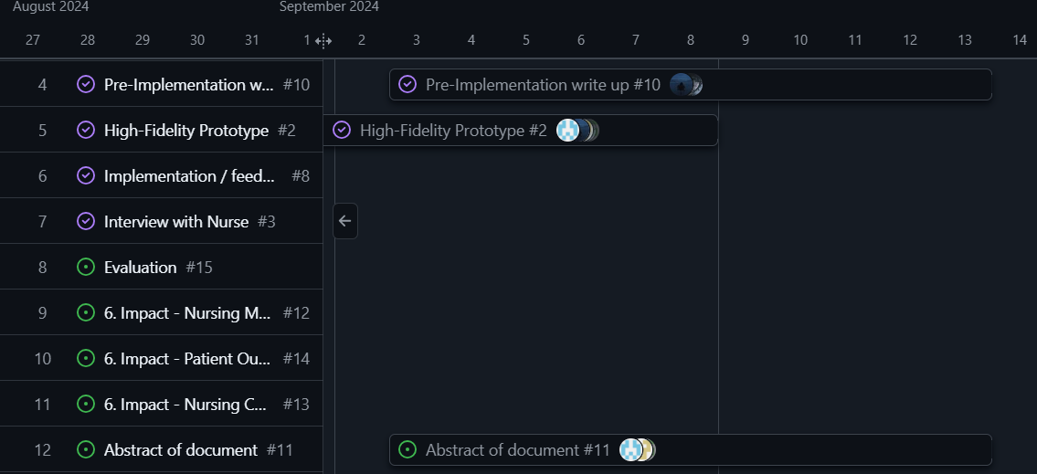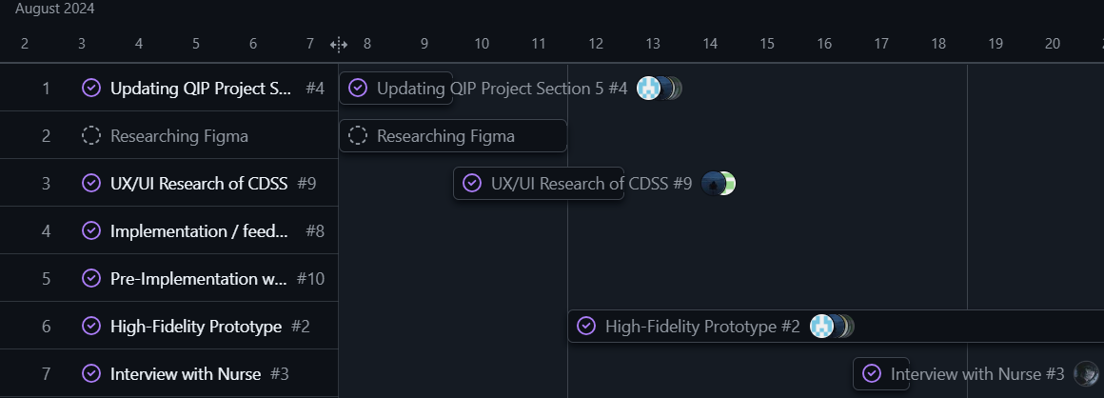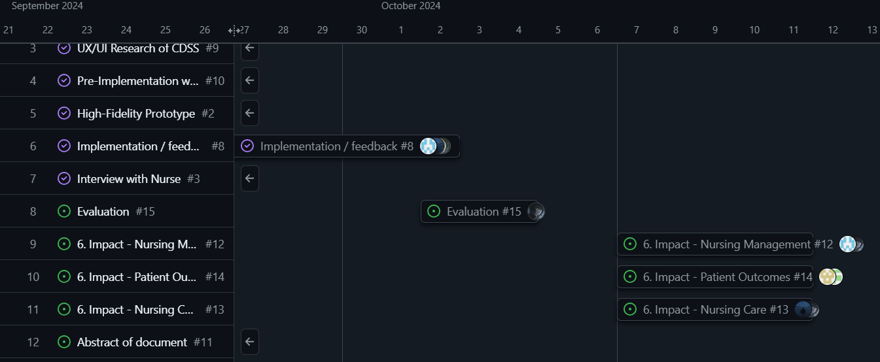

### Recommendations

Figure 1: Gantt chart of QIP project

In terms of the implementation, it was suggested that as part of the system, there is a feature to view progress on patient health for continuity of care delivered. There should also be input for demographics such as age or gender which would affect the risk assessment process.

We also recommend that there is more engagement from the BIT faculty and university in terms of the healthcare elective module. It would help gain permission to conduct research in hospital wards for the QIP project and have BIT students on a more even ground with the nursing students.

It is concluded from the questionnaire that the implementation of a CDSS would prove beneficial for the oncology wards, especially among the younger nursing staff. Training would need to be in place, but overall, it would assist them in the health risk assessment process. It also raised awareness of a different approach to assessing patients within the oncology wards and the idea that such a system could also be used within other wards. Therefore, with the knowledge and feedback from the interviews, the system would improve health risk assessment and effective health care delivery.

# 6.IMPACT

## Nursing Management

## Nursing administration in cancer wards will see big changes with the use of a Clinical Decision Support System (CDSS). This system gives real-time alerts and suggestions based on patient symptoms, helping nursing managers make better decisions with their teams. By using data, nurses can cooperate more easily to meet the needs of patients. The system can be used in different management roles. At the top level, nursing managers can set rules for how it is used. They can also improve patient care by checking results and reviewing how well staff are doing their jobs. At the tactical level, they can give advice to specialists and help educate patients about their treatment options. At the operational level, the CDSS can help identify where nursing staff need more training, so they can use the system well. The system aims to make work processes smoother and manage resources better, which will result in improved patient care. It also supports continuous learning and improvements in cancer treatment practices.

## Nursing Care

The CDSS will make diagnosing and assessing patients easier, helping to modernize and improve nursing care. Nurses will have access to symptom analysis, which helps them give better and quicker care. By watching patient symptoms and getting treatment suggestions, nurses can build stronger relationships with patients, creating trust and effective communication. The CDSS also helps nurses learn about the latest cancer treatments and guidelines, so they know the best ways to help. This enables nurses to deliver effective care when addressing patients’ needs, leading to more positive experiences for those in the oncology ward.

## Patient Outcomes

Implementing the CDSS is anticipated to greatly improve patient outcomes. With prompt alerts and suggestions, patients are more likely to obtain early diagnoses and suitable treatments, potentially increasing survival rates and enhancing overall quality of life. The system can provide personalized treatment suggestions based on symptom analysis, making sure care meets each patient's unique needs. The CDSS also helps protect patients by lowering the risk of diagnostic errors and issues that can result from wrong diagnoses. This means patients can look forward to a healthcare experience that is more effective, efficient, and caring, which can lead to better health and greater satisfaction with their care.

7.CONCLUSION

In conclusion, the implementation of a Clinical Decision Support System (CDSS) in oncology wards shows promising potential to transform the current practices in cancer diagnosis and treatment. Using this technique can reduce diagnostic delays, which are a major problem in the medical field, especially in oncology, where effective treatment outcomes depend on early detection. The project has demonstrated that CDSS can improve decision-making efficiency, offer personalised treatment plans, and ultimately lead to better patient outcomes.

Despite the constraints encountered during the project, such as limited access to real-world testing environments and time limitations, the feedback gathered from healthcare professionals’ points to a strong support for the integration of CDSS into clinical workflows. This backing demonstrates how the system may lower diagnostic errors, improve patient satisfaction, and improve the standard of healthcare delivery.

Looking ahead, further development and refinement of the system are essential to overcoming existing challenges. For it to be widely used, issues including data protection, system integration, and user training must be addressed. In addition, expanding the CDSS beyond oncology wards to other areas of healthcare, such as primary care and mental health, can broaden its impact. The system will continue to be a useful instrument for enhancing healthcare delivery if it is continuously monitored and improved in response to user input and technical development.

In summary, while the initial implementation faced obstacles, the potential benefits of CDSS in enhancing healthcare outcomes, particularly in oncology, are clear. CDSS has the potential to significantly improve patient safety and care quality in the healthcare system with additional training, development, and institutional support.

# References

Agency, I. A. (2023). *Strategic document development*. Retrieved from International Atomic Energy Agency: https://www.iaea.org/services/key-programmes/programme-of-action-for-cancer-therapy-pact/strategic-document-development#:~:text=Skip%20to%20main,Terms%20of%20Use

Chieh-Liang Wu, C.-T. K.-J.-C.-C.-H.-D.-H.-A. (2021, April 25). *Implementation of an electronic national early warning system to decrease clinical deterioration in hospitalized patients at a tertiary medical center*. Retrieved from National Libray Of Medicine: https://www.ncbi.nlm.nih.gov/pmc/articles/PMC8123282/

Council, S. A. (2020, June). *SANC-competencies-oncology-nurse.* Retrieved from South African Nursing Council: https://www.sanc.co.za/wp-content/uploads/2020/06/SANC-Competencies-Oncology-Nurse.pdf

Council, S. A. (2024). *Competencies for oncology and palliative nursing.* Retrieved from South African Nursing Council: https://www.sanc.co.za/wp-content/uploads/2020/06/SANC-Competencies-Oncology-Nurse.pdf

Davids, J. M. (2006, April). *Continuing professional development in nursing.* Retrieved from SunScholor: https://scholar.sun.ac.za/server/api/core/bitstreams/0fcdd91b-ddf7-4732-8c7b-e9add17ff700/content#:~:text=The%20primary%20aim%20of%20continuing,to%20their%20patients%20and%20clients.

Dr. Tiffany Avery, C. M. (2020, August 31). Understanding evidence-based practice in oncology*.* Retrieved from Nant Health: https://nanthealth.com/resources/articles/evidence-based-practice-in-oncology/#:~:text=Evidence%2Dbased%20practice%20is%20the,clinical%20trials%20for%20similar%20diagnoses.

Jerry, S. (2020, January 09). *Defining standardization and personalized care*. Retrieved from MedicalGPS: https://blog.medicalgps.com/defining-standardization-and-personalized-care/#:~:text=Standardization%20in%20healthcare%20is%20often,while%20adhering%20to%20fiscal%20responsibility.

Johnson, M. R. (2024). *Principles of oncology nursing.* Retrieved from Scribd Logo: https://www.scribd.com/document/598768495/Principles-of-Oncology-Nursing

Organization, W. H. (2024). *Ensuring quality cancer treatment*. Retrieved from World Health Organization: https://www.who.int/activities/ensuring-quality-treatment-for-cancer#:~:text=Cancer%20diagnosis%20and%20treatment%20programmes%20aim%20to%20cure%20or%20considerably%20prolong%20the%20life%20of%20patients%20and%20to%20ensure%20the%20best%20possible%20quali

Programme, N. C. (2023). *National cancer control programme - Latest information*. Retrieved from National Cancer Control Programme: https://www.hse.ie/eng/services/list/5/cancer/#:~:text=National%20Cancer%20Control%20Programme%20%2D%20Latest,evaluation%20into%20strategies%20and%20actions.

Randa Elsheikh, L. L. (2023, October). *The role of nursing leadership in promoting evidence-based nursing practice*. Retrieved from ScienceDirect: https://www.sciencedirect.com/science/article/abs/pii/S8755722323001035#:~:text=Nurse%20managers%20and%20nursing%20educators,EBP%20implementation%20in%20nursing%20practice.

Staff, C. (2023, December 1). *What is an oncology nurse? And how to become one.*  Retrieved from Coursera: https://www.coursera.org/articles/oncology-nurse

Technicians, N. R. (2024). *National continued competency program*. Retrieved from National Registry Of Emergency Medical Technicians: https://www.nremt.org/Document/nccp#:~:text=HOME,Emergency%20Medical%20Technicians

Town, U. O. (2022). *Evidence-based practice guidelines*. Retrieved from University Of Cape Town: https://health.uct.ac.za/childrensnursingunit/EBPG#:~:text=Skip%20to%20main,%7C%20PAIA.

Victoria, D. O. (2021, October 26). *Implementing evidence-based practice.* . Retrieved from Department of Health Victoria: https://www.health.vic.gov.au/patient-care/implementing-evidence-based-practice

# Annexure A

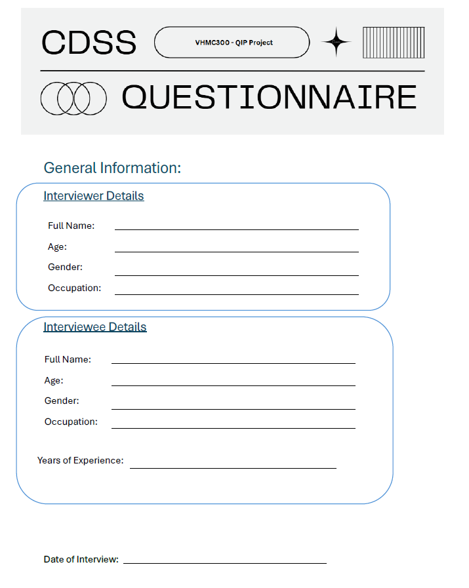

# Annexure B

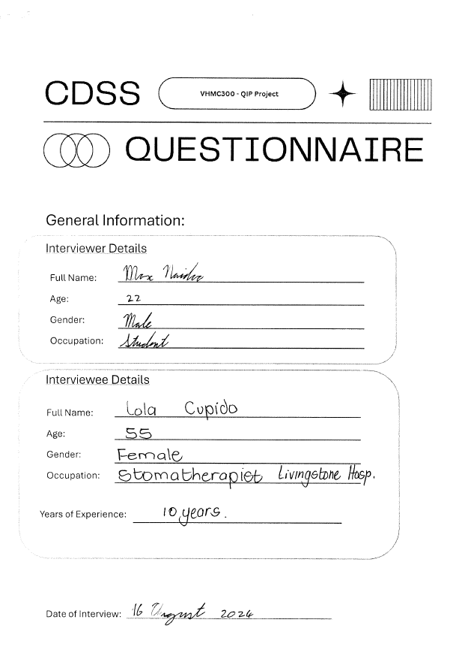

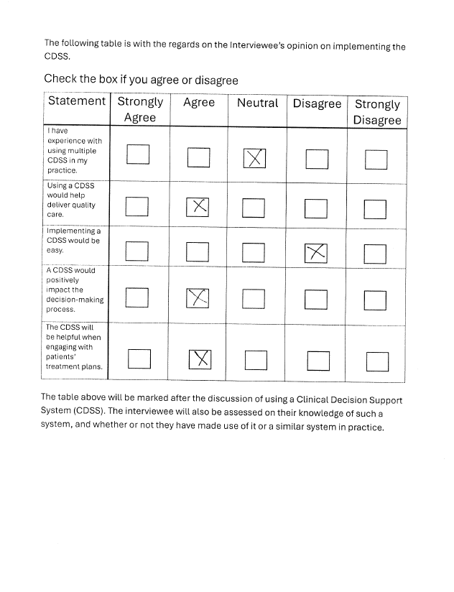

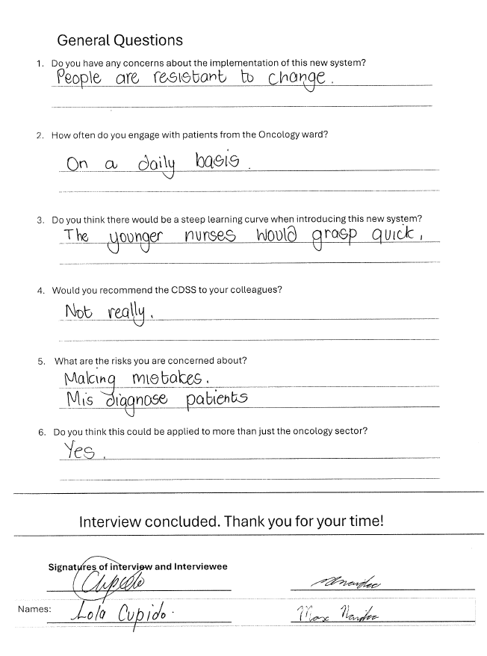

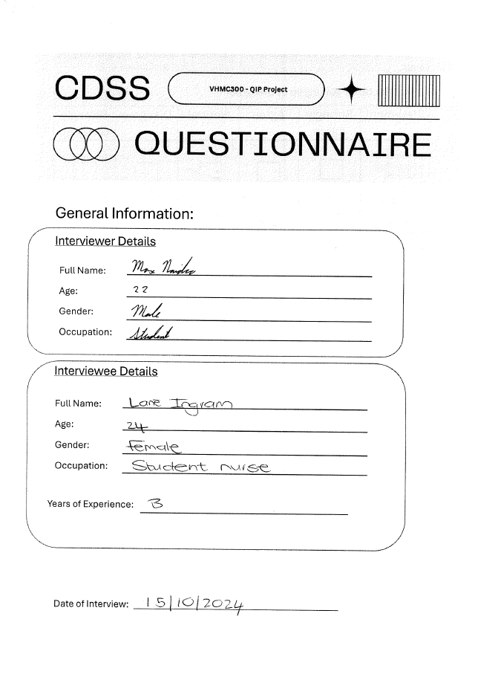

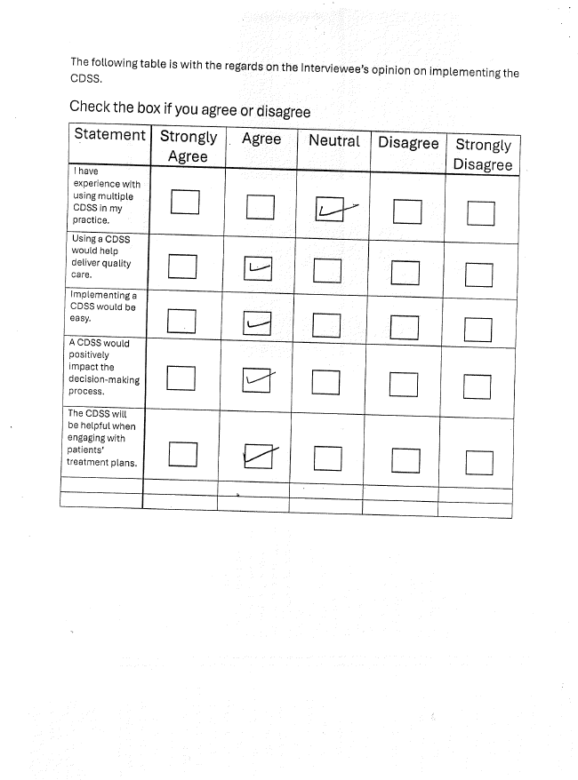

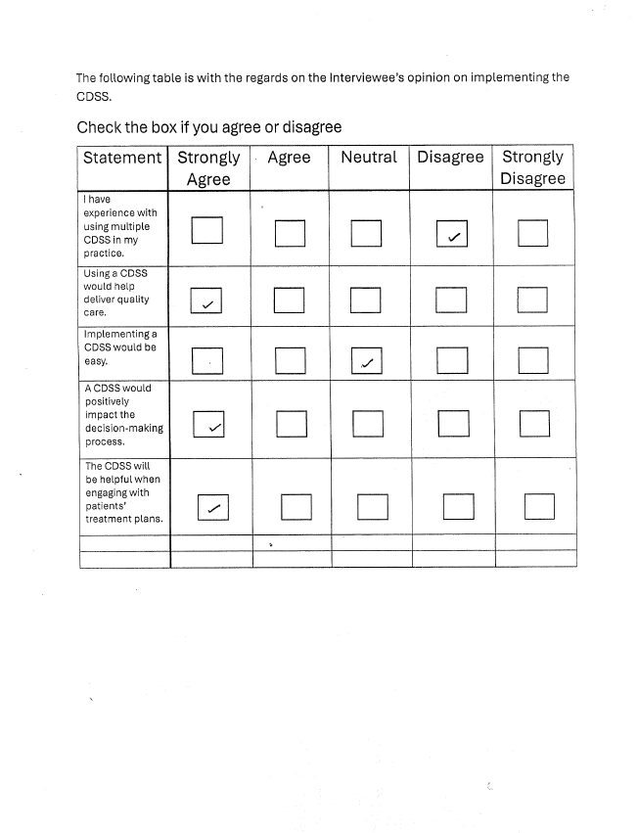

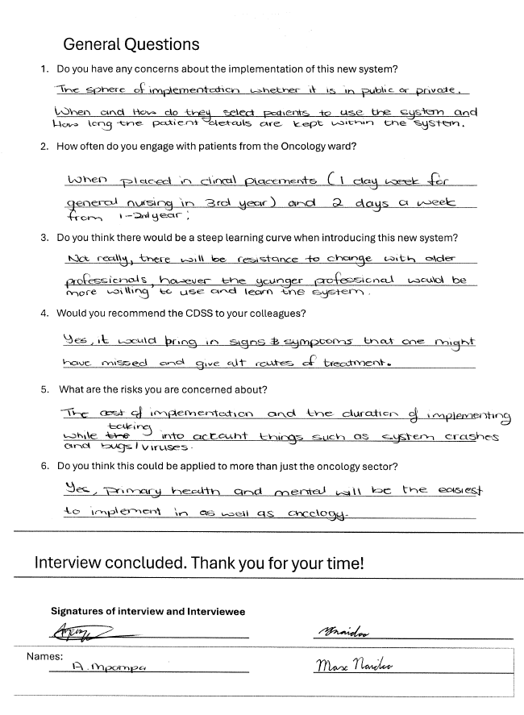

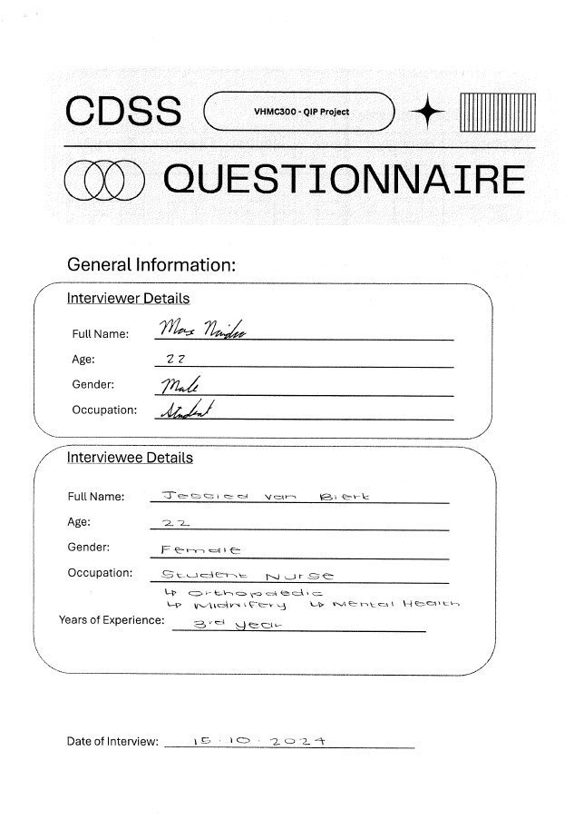

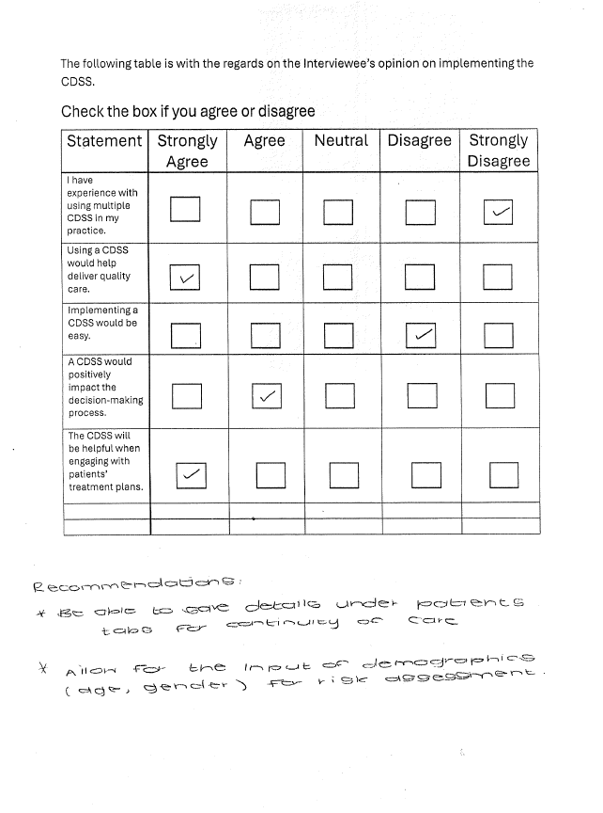

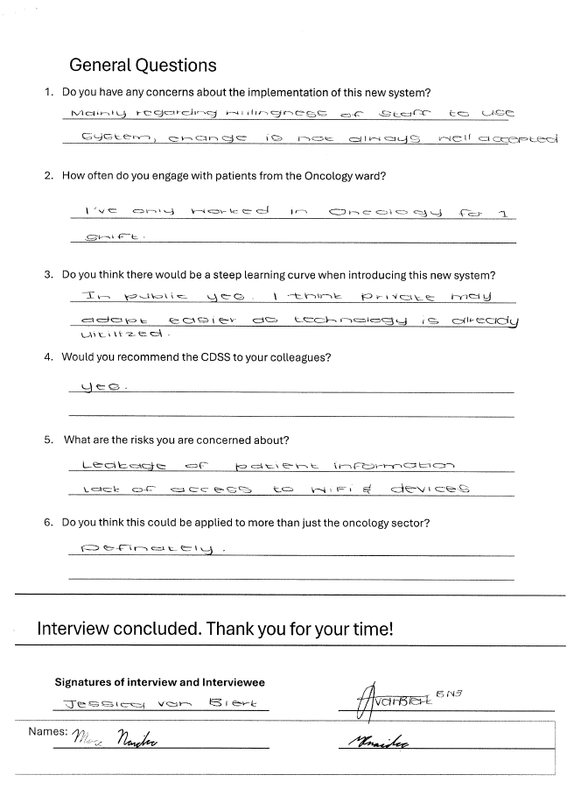

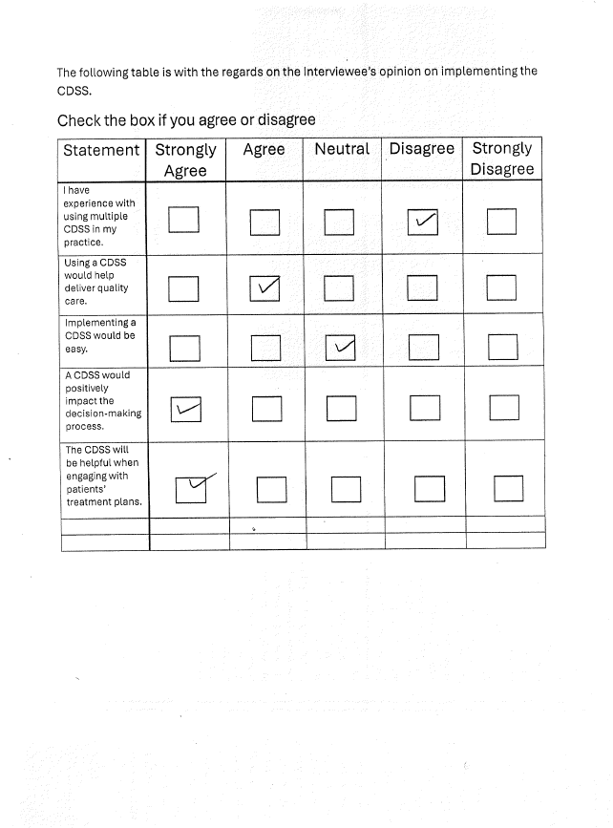

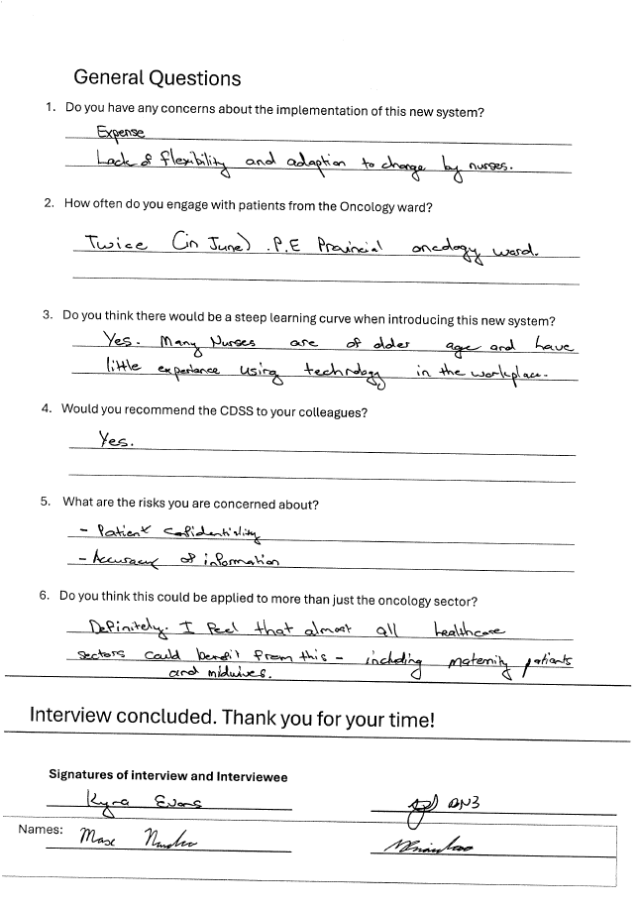

# Annexure C

